



**UNIVERSITY OF RWANDA**

**COLLEGE OF BUSINESS AND ECONOMICS**

**SCHOOL OF BUSINESS**

**BIT DEPARTMENT**

**LEVEL 2**

**GROUP 2**

**PROJECT DESCRIPTION**

**ON**

**WINE AND LIQUOR STORE MANAGEMENTS YSTEM**

**Names: MANIRAGENA Viateur**

**Registration number: 221013244**

**Class number: 023**

**WINE AND LIQUOR STORE MANAGEMENTS YSTEM**

**WINE AND LIQUOR STORE MANAGEMENTS YSTEM**

**INTRODUTION**

The Wine and liquor Store business is an enticing enterprise. But managing how the alcohol gets to the customers can be quite a process. The Wine and liquor Store owners simply must have the right Store management software in place. Without the right system, Store owners can miss out on sales opportunities and get overwhelmed by inventory.

The Wine and liquor Store management system is a business management solution for retailers or owners that will help them to manage inventory (stock), sales operations and retail accounting operations and other activities of Business. It is composed of tools and programs to manage and in many cases automate Store process.

The Wine and liquor Store management system provides the features that are available to Wine and liquor Store retailers, managers or owners, such as expedite transactions, auditing to avoid theft and loss, profit or price management or gift giving (discounts).

Example: The Wine and liquor Stores often offer loyalty programs to keep customers returning. They may need some information of their client, like contact and address details and purchase history, so that Stores can reward their most valuable customers.

**GENERAL OBJECTIVES**

* **Centralized Management:** This is the key to the success of Wine and Liquor Store business whether you have one location or a multi-location operation. Having global access to all activities such as sales and inventory reporting will help the owners or managers analyze their business’s profit and build a strategy for a better outcome as good as maximizing profit.
* **Manage Inventory:** Easier way to make analysis on Store to determine what you have, making the most of what you have, and using the insights gained to make more informed purchases and decisions. This will help to prevents Store from running out of stock or other loss and overcome challenges.

Small or big inventories, it will facilitate them to keep tracking of how much product they have and the types they have, followed by monitoring which sell best and which do not. This will them to make better decisions in the future.

* **Control and Speed up transactions:** the payment for transactions will be delivered quickly and faster than current method of payments, through the system. The transactions will be automatically saved in database and this will minimize time for waiting to clients and accelerate good service.

But also it will help analyzing and making reports for even possibly short period of time. (For Example, If Retailers/managers what to know a time Store use to have high number of customers, what kind of products they like most, ….)

* **Avoid Theft:** it is common for employees to make a sale and then simply remove the items from the transaction if the customer pays cash, allowing them to pocket the money.

But this system recommends the best practices on retail loss prevention like using the individualized sales reports for each cashier to identify any concerning trends, which means every cashier/employee will have his/her own account/password to login to the system.

This will help to limit the access of the employees to Store’s data and goods based on their job role and position.

**SPECIFIC OBJECTIVES**

* **Get helpful reporting and analytics:** The Wine and liquor Store system management will provide reports and analytics, so the managers can plan the future growth. With the right analytics, they will be able to not only buy the correct amount of Wines and Liquors needed to demands, but also generate promotions around bestselling pairs.

Potential opportunities to increase sales based on analytics include changing customer preferences, optimizing drink recipes, apply discounts and more.

* **Employee auditing:**  One of the key management reports is the employee audit, which looks at profitability and transactions by employee. This helps to protect the bottom line and prevent inventory shrinkage by holding employees accountable.
* **Make use of integrations and security:** The Wine and liquor Store system management makes the inventory process even easier. It also helps to provide knowledge about sales and how to make improvement.

This system integrates with existing technology and includes all the tools needed in one system and linking security recordings with transaction records.

* **Reduce waste:** Beyond being unnecessary, waste is costly and a barrier to maximizing profits for Store. Taking regular inventory allows you to be aware of where waste is happening, whether it’s beyond what is required, understocking or not using the most profitable brands of Wine and Liquor.
* **Optimize time:** Inventory is mostly time consuming process. The system helps to reduce amount of time spent in back room, counting each and every bottle there and calculating endless Store inventory formulas.

Instead of spending all of work time counting stock, you can better spend it serving customers and improving business overall. The system not only saves you time, it quickly and easily provides insights beyond what you can get manually.

**PROBLEM DESCRIPTION**

Running Wine and liquor Store of today has many challenges and most of the time inventory is the root of many of those problems. Today’s wine and liquor Store has its unique problems and these are most issues to be solved by this system as below:

1. **The challenge of inventory tracking:** keep tracking different products (many types of wine and liquor) with different flavors and bottle size is hard task and it is simply complicated to deal with such a large product assortment.
2. **Employee Theft:** in many retail businesses the employee theft is also concerned. Sometimes employees make a sale and then remove items from the transaction. However, Wine and liquor Stores are especially impacted, this mainly due to a lack of inventory tracking because of many managers and owners are not aware on this issue. If you don’t know what you are supposed to have you can’t ever know when something goes missing.
3. **Insufficient of reporting on inventory management:** With large product catalogs, it is difficult to know what an item is actually making business profitable and which one is taking loss.
4. **Supplier/Customer management:** it is not easier to make reviews from archive. Example, let’s assume that a client returns product he/she brought about 1 month ago, it will take time of verification and ever to know where those records Stores is too difficult and. As a result, record keeping is complicated.
5. **Financial and accounting reports:** report procedures will be long, process of collecting and correcting different reports from different sides and due to make general report (like ledger) efficiently and the result could not be good as every employer expect.

**DESIGN**

The Wine and liquor Store management system: is the system which is very helpful because it is based on store site for management and control wine and liquor store ,I t is designed in Net bean software through its graphic interface which is connected with database for functionality , in order the user to access the system to perform their roles they have to log into the system and system have to check whether the user credential is comply with that in the database.

So through this system there are three users which are: manager, store keeper and cashier.

Each user among them have to login into the system to perform their responsive services :

Let us look for each system users:

1. **Manager:** who has to manage , control whole store and update the system users or employees and is only one who has ability to change the users credential for forgotten username and password.
2. **store keeper :** who has to deal with stock by recording new entered stock of product and check who supplier supply those product received, he/she also deals with recording the new supplier of new product and is view stock report and ensure stock updates.
3. **Cashier:** this user in system is responsible for selling the product(liquor and wine) and giving discount to the customer and has responsible to update the customer’s information and record new coming customer.

**FUNCTIONAL REQUIREMENTS**

These are requirements which describe ways a product must behave such as product features, what the product does and focus on user requirement. They allow us to verify whether the application provides all functionalities needed in the application’s functional requirements. They support tasks, activities, user goals for easier project management.

The following are functional requirements which are needed in Wine and Liquor store management system:

* **Business requirements**: it involves the requirements that Store needs to operate business functions. And also describes the rules of business. For example, Wine and Liquor store may include a functional requirement that allow cashier to make discounts to customer who buy many quantities.

These requirements mention what are features system needs so business can achieve its goals.

* **Transaction corrections, adjustments and cancellations**: these requirements examine every transaction’s entry, changing, deleting, canceling, and error checking. The system provides a receipt to users upon performing a transaction, and the system records information about the transaction.
* **Authentication functions**: ensure that users validate their identifications before performing certain system functions. It may involve requiring users to inter a password and username. These concern the information users share with system and their authentication levels.
* **Authorization levels:** these functions determine various system access levels and decide who can change, read, update, or delete information.

For example, Admin is only one to create user accounts and access whole system; Stock keeper can change read and update; Accountant can read, update and delete; Cashier can create, read and update his/her transactions. And Manager can change, read, update information.

* **System requirements:** involve specifications for software and hardware such as computers, database and more. These also include the specific actions that s system takes to complete a task.

They include how system responds under special circumstances. For instance, if software detects a security breach, it may deny all access to users temporarily.

* **External interfaces:** these are user preferences which help individuals operate system easily. It may involve specific features like the interfaces of software, navigations and more.
* **Administrative protocols:** Allow system to perform special operations include system reporting and testing to ensure the system runs properly.
* **Audit tracking:** this is process which helps to track critical data like business reports, inventory managements, and more

**TECHNICAL REQUIREMENTS**

Are those functions that help system operate efficiently, rather they define how the system should perform. Are also those requirements have no functions to the user of the system in his or her task which means that are not mandatory for system to have, though they typically increase a software’s overall quality, speed and storage capacity.

For example, if user prefers their software to have larger amounts of data storage, they will choose a software system that has nonfunctional requirements involves more storage space like this one (The Wine and liquor Store management system).

The non-functional requirements that are to be included in The Wine and liquor Store management system include:

* **Usability**: The user Interface should be simple enough for everyone who has to use this system. It involves specific features that help users operate software. The system must be user friendly, for example; uses of verbal language.
* **Scalability:** This system determines this feature as scale of data maximization that needed to be saved. Having system that’s scalable involves expanding storage space to allow for more saves information.
* **Reliability**: involves features that analyze and increase the reliability of system. In this system, it is important for users to have reliable software so that their information is secure from potential security threats or data loss.
* **Maintainability**: this system should be easily maintainable and adding new feature or making a change should be done easily.
* **Security**: security features involve adding protocols to protect valuable data. In my concern I have to deal with the security of system database in order to make sure that stored data are more secured.

For example, The Wine and Liquor Store may add extra security protocols like firewall, for users accessing transaction information to ensure the Store data remains safe.

* **Performance**: typically, the level of speed the system has is important for users, since they may want a system that works quickly. This requirement boost computer’s speed and efficiency.

For example, if a cashier submits transaction, having high speed will help in customer care treatment.

**DEVELOPMENT**

After project research and plan we decided the way we can pass through for developing our project, firstly we thought on the real structure of this system and we tried to make a project sketch by using **Drow.io software.** When we were drawing we indicate the user of the system and their specific role. These sketch is called **Data Flow Diagram all levels** which shows the flow of data and it also show the role played by each user.

After planning and design, we created database to store the user’s information stored in tables which consist of users: Manager , cashier , store keeper and other information of customers , suppliers, product making Relationship between them via their primary key and foreign key.

After creating database we design our system by using **Net bean** **software** in order user to get Graphical user interface for performing their activities so after these we connected database with net bean in order user to access information by using **MYSQL connector**.

**4.TESTING**

After designing our project we have tested step by step to check if it is running properly and checking whether it is solving the problem that we have been mentioned and checking whether the result provided is comply with the problem we have found.

These all is done by testing and our project is designed in way that every users have to login in order to perform their specific activities :

Let us test by going through step by step from user login to the performing activities:

We have three users: store keeper, manager , cashier. Each user has his/her task to be performed but for each also has to first login and system make checkup to check if provided credentials are met with those kept in database.

On picture below it shows that users are required to provide user credentials

Let us start with **cashier**

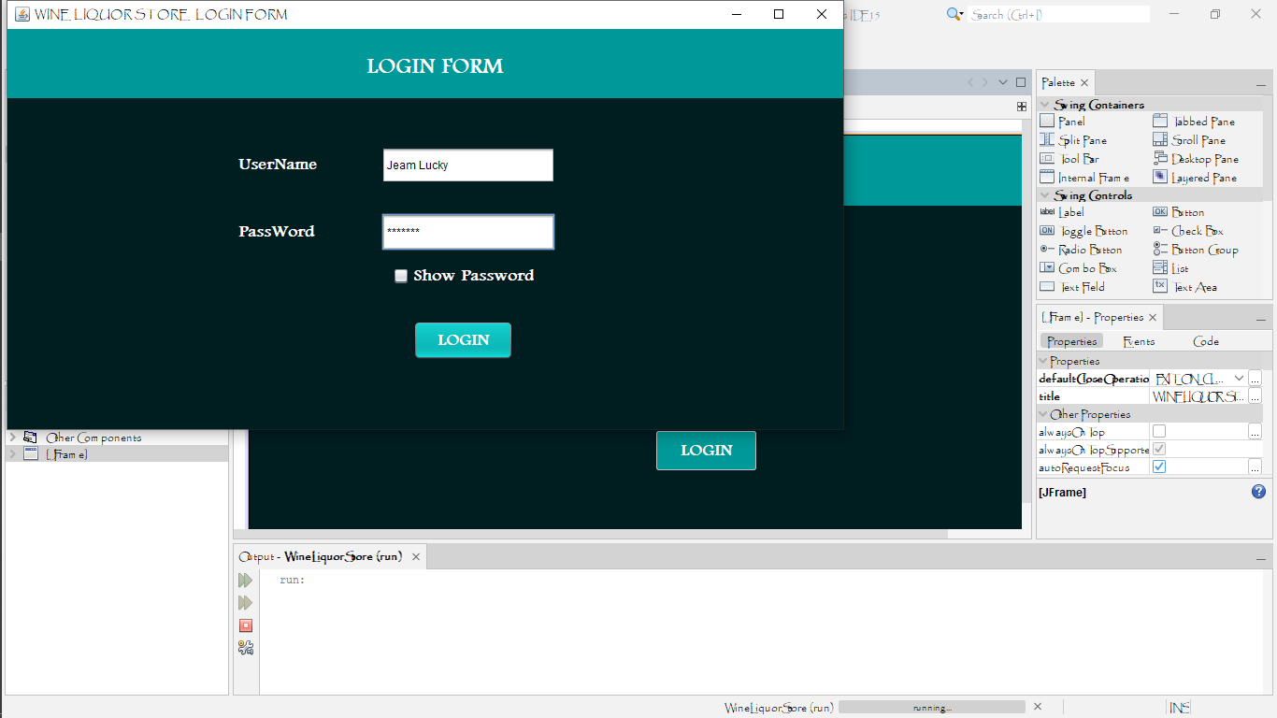

Cashier provided his credentials and system make check and allow him or her to access ather activities to be performed like provide service to customer, view product list, sales data and other activities.

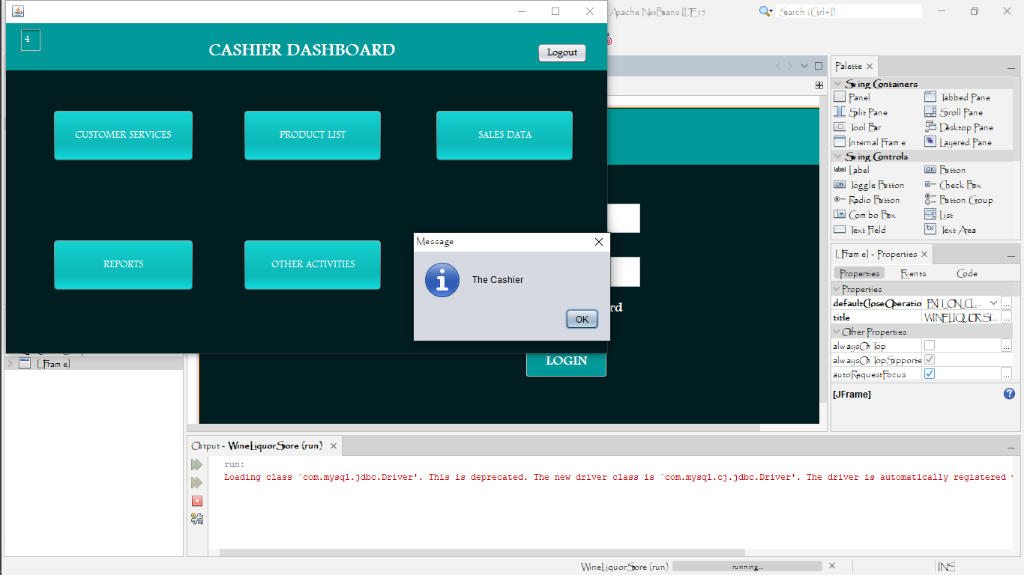

If these cashier is unable to provide real credential system will not allow him or her to login and access other activities.

And system provide message “check if your username and password are correct”.

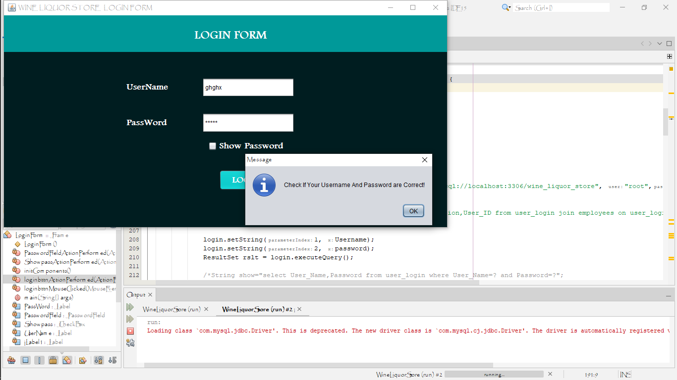

After login he /he can access customer form in order to sell product

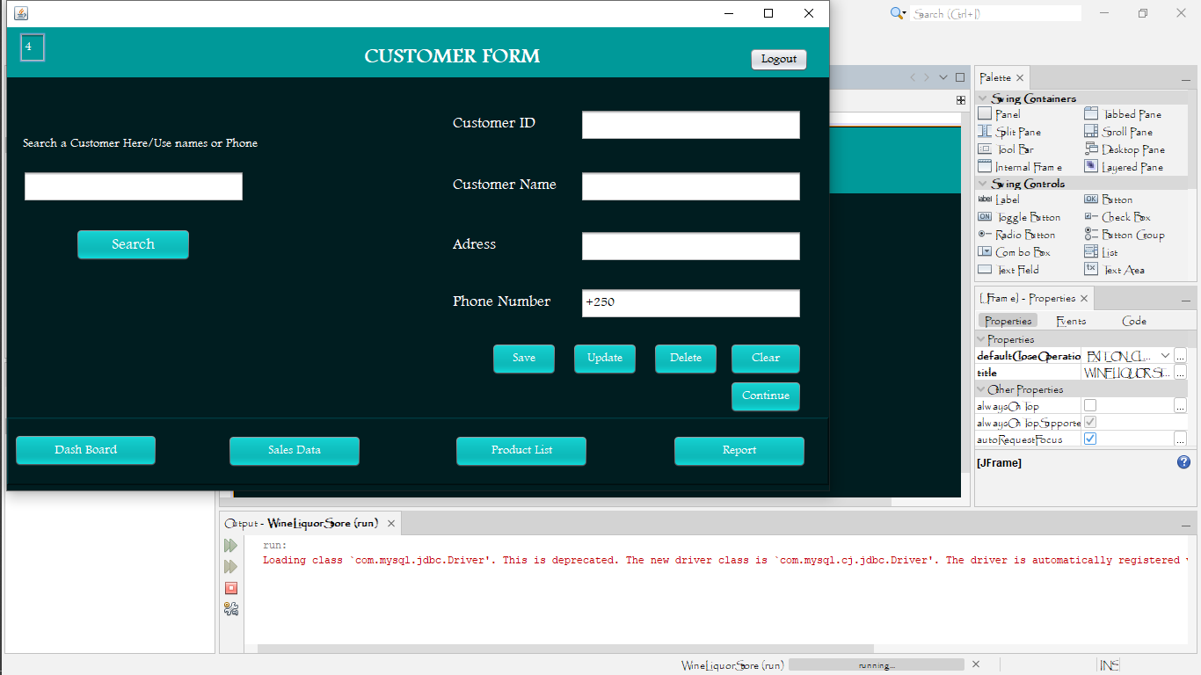

And he can access the sales form to view sales info

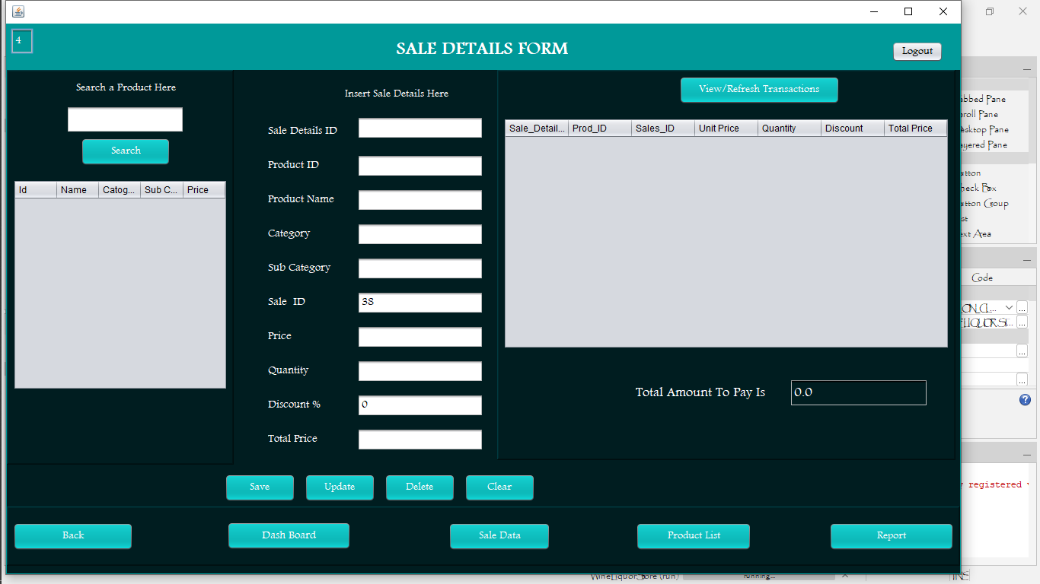

**Note:** these are step to be passed by every user and access his specific activities

**5. Deployment**

Once the software has undergone testing and quality assurance (QA), it is delivered to the customer. This stage usually involves deployment engineer who make software available to customers. They may install the software at a company and/or help individual customers run the application on their computers.